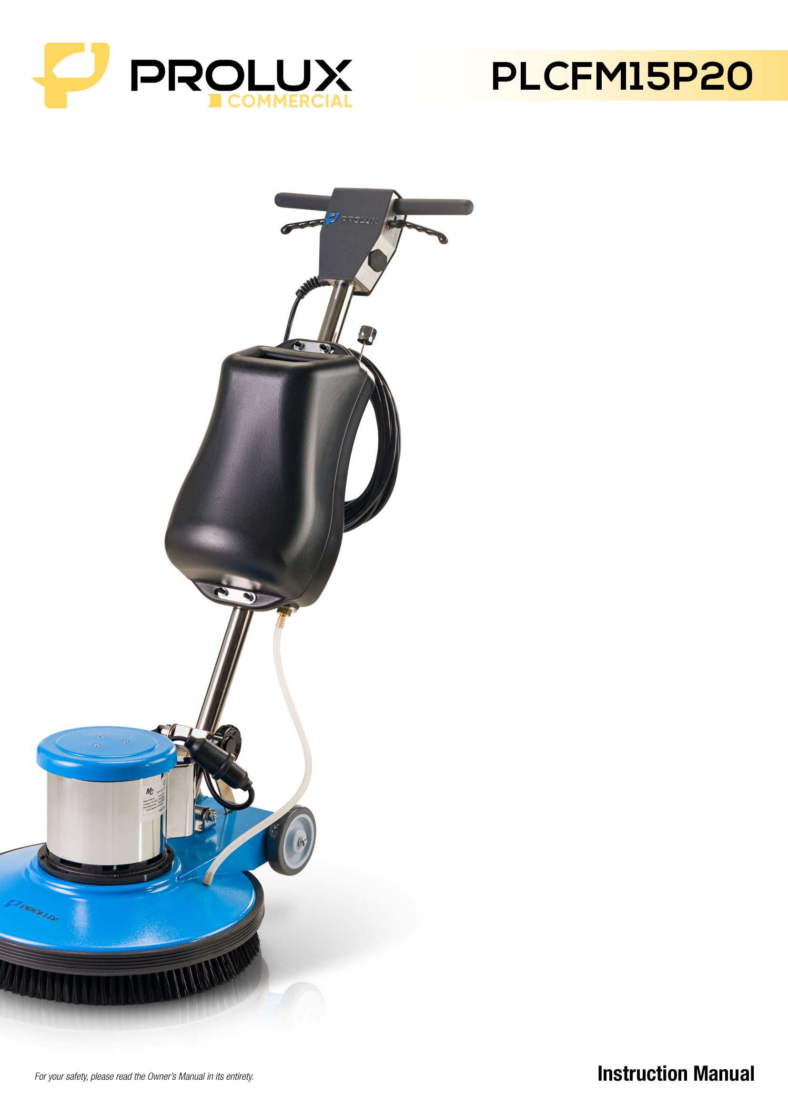

**CONTENTS**

1.0 Operate Safety Instruction

2.0 Machine Introduction

2.1 Accessories

2.2 Technical Specifications

3.0 Prepare the machine before operation

3.1 How to install the Brush and Pad Driver

3.2 How to adjust the Handle

4.0 Power connection

5.0 How to operate the machine

5.1 How to start/stop the machine

5.2 How to control the machine

6.0 Maintenance

7.0 Troubleshooting

1. **Operation Instructions**

|  |
| --- |
| Please read this manual carefully before using this appliance  In this manual, there are common safety instructions in details on appliance preparing, operating and maintenance. And operator must obey these accident preventive regulations when use this machine. Any accident aroused by regulations disobey, producer will not bear any liability. |

This manual is also one of the important attachments of this appliance, make sure the operator read or listen to the professional person’s introduction on this manual. Save the manual in the place where you can easily fetch and regular read. This manual adopts the following three kinds of figure as the important indication:

 **INDICATION:**

**Key information on economical using.**

**The possible accident aroused by disobeying the manual.**

** NOTICE:**

**The possible accident and estate damage aroused by disobeying the manual**



**FORBIDDANCE**

**The possible severe damage to person and estate arouse by instruction disobeyed.**

**Safety Notice**

**If try to operate or amend this appliance before reading this manual, it will possibly damage the operator or other person nearby. So training is needed before using, If the operator cannot understand this instruction, please teach him hot to operator this appliance.**

**To reduce the risk of fire, use only commercially available floor cleaners and waxes intended for machine application.**

**Risk of explosion, Floor sanding can result in an explosive mixture of fine dust and air. To reduce risk of explosion, use floor sanding machine only in ventilated area.**

**Operating a machine that is not completely or fully assembled could result in injury or property damage. Do not operate the machine until it is completely assembled. Inspect the machine carefully before operation.**

**Electrocution could occur if maintenance and repairs are performed on a unit that is not disconnected from the power source. Disconnect the power supply before attempting any maintenance or service. Always remove the electrical plug from the electrical outlet before changing the brush, pad or other attachment and before leaving the machine.**

**Use a machine with a damaged power cord could result in an electrocution. Do not use the machine if the power cord is damaged. Do not use the electrical cord to move the machine**

**Maintenance and repairs performed by unauthorized personnel could result in damage or injury. Maintenance and repairs must be performed by authorized personnel only. Keep all fasteners tight. Keep adjustments according to specifications.**

**Electrical components of this machine can “short-out” if exposed to water or moisture. Keep the electrical components of machine dry. Wipe the machine down after each use. For storage, keep the machine in a dry building.**

**Always use a three-wire electrical system connected to the electrical ground. For maximum protection against electric shock, use a circuit that is protected by a ground fault interrupter. Consult your electrical contractor.**

**To prevent damage to power cord, do not let the brush, pad driver and wheels move over the power cord when the appliance is working. Keep the power cable higher than appliance.**

**Operating a machine without observing all labels and instructional information could result in injury or damage. Read all machine labels before attempting to operate.**

**Use of this machine on a step or furniture could result in injury or damage. Do not use machine on a step or furniture. Do not ride on this machine.**

**To avoid injury, keep hands, feet and loose clothing away from all moving parts of this machine.**

** Injury to operator or bystanders could occur if an abrupt change in floor surface texture is encountered when using this machine. Abrupt change in floor surface texture can cause a sudden pulling motion by this machine. This sudden pulling motion can result in loss of control of the machine which could injure the operator or bystanders. Avoid motions that could cause machine to cross from a smooth floor surface to a carpet or rough texture floor surface. Avoid motions that could allow the machine to come in contact with low obstacles, such as floor electrical outlets, door stops or entry molding, etc.**

**Water solution or cleaning materials used with this type of machine can leave wet areas on the floor surface. These areas can cause a dangerous condition for the operator or other persona. Always put CAUTION signs near the area being cleaned.**

**The appliance is heavy. Get assistance before attempting to transport or move it.**

1. **Machine instruction**

FM430Q/FM430 Single Disc Scrubber is a multifunction floor scrubber appliance, it is favorable in strong adaptability, simple reliable construction, smooth working, huge measurement of solution tank, this appliance can basically meet the cleaning requirement on hard floor for the professional cleaning company, its quality is equal to congener goods outboard.

**M430P** equips a larger motor,2HP motor, appliance weight will be up to 80kgs after fitting the extra weight block, this type can be used on clean, polish work required high pressure.

**2.1 Accessories**

A pad driver B brush(option) C water tank(option) D additional iron piece(option)

Note: No recommend additional iron piece using on 750W appliance

* 1. **Technical Data**

**KEEPER Multifunction Floor Scrubber**

|  |  |  |  |
| --- | --- | --- | --- |
| **TYPE** | **FM10P** | **FM15P** | **FM20P** |
| **POWER(W)** | **750** | **1100** | **1500** |
| **VOLTAGE(V)** | **230V** | | |
| **FREQUENCY(Hz)** | **50** | | |
| **ELECTRICAL CURRENT(A)** | **5** | | |
| **CABLE SPECIFICATION** | **227 IEC 53(RVV) 300/500V 3G 1.5mm2** | | |
| **BRUSH PLATE DIA.(mm)** | **430** | | |
| **PAD DRIVER DIA.(mm)** | **430** | | |
| **BRUSH PLATE ROTATION SPEED(rpm)** | **154** | | |
| **CABLE LENGTH(m)** | **12** | | |
| **WEIGHT(kg)** | **45** | **60(with 1 weight block)** | **80(with 2 weight block)** |

1. **How to prepare the machine for operation**

****Please pull off the power plug from electrical outlet before installing or replacing the pad driver, brush and other attachments.

3.1 **How to install brush or pad driver**

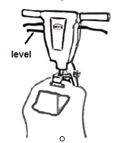

To install brush pad, follow the steps on below:  
1,Pull the level in Figure 1, and adjust the handle in the suitable position for you,

2,Tilt the machine backward until the handle touches the floor, see Figure 2,

3,Put your feet on each side of the machine, see Figure 2,

4,Align the lugs(1) on the locking plate into the brush pad

Opening(2), see Figure 3,

5,To lock the brush pad into position, turn the brush or pad driver as indicated in Figure 2(A),

6,To unlock and remove the brush, turn the brush or pad driver as indicated in Figure 2(B).



**NOTE: To prevent any damage to the brush or pad driver, remove the accessory while not in use. Keep the brush in cool, dry place.**

**Figure 1**

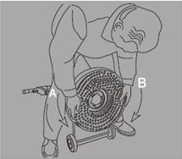

**Figure 2**

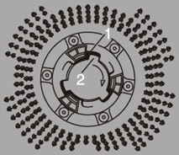

**Figure 3**

* 1. **How to adjust the handle**

To adjust the handle, please follow the steps below:

1. Pull up the level in Figure 1, and adjust the handle
2. Lower the handle to the best operating position

**NOTE: For the best operating position, keep your back straight, bend only your arms.**

1. Hold the handle against your body for the best control
2. **Power Connection**

****This appliance is just adapted for alternating current, please check whether the local voltage is matched. Do not drag the appliance with the power cord.

**This appliance must use the power with grounding protect to prevent the risk of electrical shock. And the outlet box should be grounded.**

**This appliance equipped a 12 meters’ long power cord which has a 1.5mm2 cross section, try your best not to use the extra power cord, if it is really needed, please use the cord with cross section above 1.5mm2 , and its length should be within 10 meters.**

****The same extra cable can not supply multi appliances, or the too huge voltage will affect the normal operating, also this will damage the appliances.

5.0 How to operate the machine

5.1 How to start/stop the machine

****Never start the appliance when the handle is vertical position. Also a start lock construction is designed, in order to avoid mistake operating when the handle is in vertical position.

****Both hands should be hold on the handle when start the appliance

Start the appliances based on following steps, see Figure 4:

1,Pull up the level, adjust the handle to your suitable position.

2,Press the knob switch (on the rear handle cover)  
3,Pull up the start level 1(both sides), start the appliance.



**NOTE: In order to make sure the safety operation, this appliance adapts a special design that the appliance normally works only the both hands touch the start level at the same time.**

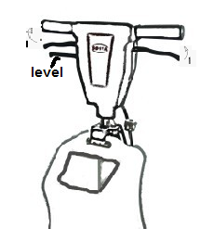

**Figure 4**

5.2 How to control the appliance

The side-to-side movement of the machine is controlled by raising the handle and pressing down on the handle. To move the machine to the left, press down on the handle slightly. To move the machine to the right, raise the handle slightly, Please master the key points, it will be easy to control the appliance.

6.0 MAINTENANCE

****Maintenance must be done by authorized person only

Daily maintenance

Remove the brush or pad driver from the appliance when the work finished, and save them in the ventilated dry place. The appliance body should be cleaned with dry cloth,, also clean the water container and check the power cord.

**The detergent liquid remains in the water container should be cleaned in time, and scour it fully with clean water. Do not remain any detergent liquid in the water tank, it will short the using life of control valve.**

**The liquid medicine spayed on the appliance surface, especially on the fasten parts, should be cleaned washed with clean water and cleaned with dry cloth in time, because any kind of cleaning liquid medicine is corrupt.**

Yearly maintenance

Return the appliance to a **MC** Authorized Service Location every 12 months for maintenance inspections or call professional person for visiting inspections.

Start button

**All electrical repairs must be done by authorized person only. The machine must be tested after electrical repairs to make sure it is safe to operate. Disconnect the electrical plug from the electrical outlet before doing any electrical repairs.**

The start and stop switch has an interlock which prevents the mistake operation. And there is a lock unit in the handle vertical position. If the start/stop switch is damaged, and can not start the appliance, return the appliance to nearest **MC** Authorized Service Center for replacing the switch and testing.

7.0 Troubleshooting

Before asking for amendment and examination, please check based on the following points. If the malfunction can not be eliminated, please contact the amendment center or local sale agency.

|  |  |  |
| --- | --- | --- |
| **Problem:** | **Possible Cause:** | **Solution:** |
| Motor operates intermittently | Power cable is lose/falls off  Power cable is broken  Switch is broken | Check all the power cable connection  Replace the power cable  Replace the switch |
| Motor does not work | Power cable looses/falls off  Power cable is broken  Switch is broken  Capacitor damaged  Centrifugal switch damaged  Loop short circuit | Check all the power cable connection  Replace the power cable  Replace the switch  Replace the capacitor  Replace the centrifugal switch  Replace the stator resistor |
| Motor rotation speed is very low | Capacitor damaged  Start loop failure | Check capacitor  Check the centrifugal switch |
| Motor rotation driving disc does not work | Connect block in gear box rupture | Replace the connect block |
| Machine stops | Electro circuit overloads  Brush overloads  Size of extension cable does not match  Abnormal use | Check the load of all electro circuit  Check, change operation manner  Replace extension cable  Consult dealer |
| Machine rocks or vibrate severely | Brush/pad driver warp or damage  Brush/pad diver are not in center position | Replace brush/pad driver  Make brush/pad driver in center position |
| Vibration noise | Motor bearing broke  Wheels loose | Replace motor bearing  Fasten the wheels |

- The guarantee does not cover accidental damage, misuse, cabinet parts, knobs or consumable items.

- The product must be correctly installed and operated in accordance with the instructions contained in this manual.  
- It must be used solely for domestic purpose  
- The guarantee will be rendered invalid if the product is re-sold or has been damaged by unauthorized repair.

- Specifications are subject to change without notice.

- The manufacturer disclaims any liability for the incidental or consequential damages.

- The guarantee is in addition to and does not diminish your statutory or legal rights.

***The information contained herein is confidential and is intended to be used by Prolux Cleaners authorized distributors and sales representatives.***

Prolux Cleaners guarantees its products according to the terms outlined below. There are no other warranties expressed or implied, including any implied warranties of merchantability or fitness for a particular purpose. Under no circumstances will Prolux Cleaners or the seller be liable for any loss, damage, expense, or consequential damage arising in connection with the use or inability to use these products. If a component fails to meet the term of the warranty due to defects in workmanship or materials, Prolux Cleaners will repair or replace the defective component free of charge, including labor according to our flat rate schedule and the Prolux Cleaners Warranty Procedures.

# **All warranties implied below are subject to the Exceptions and Exclusions clause in this policy located in this document.**

|  |  |  |  |  |
| --- | --- | --- | --- | --- |
| Product Category | Polyethylene  and Structural  Foam | Steel Body  Parts | Switches, Motors  Electrical Parts | Labor Paid |
| Machine | Years | Years | Years | Years |
| Battery Walk Behind Scrubbers 14” and 18” | 5 | 2 | 3yr Switches  3yr or 700hrs (whichever comes first) on the motor  3yr Electrical Parts  12mo Pro Rated Lithium Ion Battery | 1 |
| Wide Area Vacuum | 5 | 2 | 1yr Switches  2yr or 700hrs (whichever comes first) on the motor  1yr Electrical  Parts | 1 |
| Gel Batteries (3) (4) | N/A | N/A | 12mo of Full Coverage | N/A |
| Micro Scrubber | 3 | 2 | 12mo Pro Rated Lithium Ion Battery | 1 |
| Canister Vacuums | 5 | N/A | 2yr Switches  3yr or 800hrs (whichever comes first) on the motor  3yr Electrical Parts | 1 |
| Backpack Vacuums | 5 | N/A | 2yr Switches  3yr or 700hrs (whichever comes first) on the motor  3yr Electrical Parts | 2 |
| Upright Vacuums | N/A | N/A | 1yr Switches  2yr or 500hrs (whichever comes first) on the motor  1yr Electrical Parts | 1 |
| Garage Vacuums | 1 | 10 | 2yr Switches  2yr or 500hrs (whichever comes first) on the motor  5yr Electrical Parts | 2 |
| Wet Dry Vacuums | 10 | N/A | 2yr Switches  2yr or 500hrs (whichever comes first) on the motor  2yr Electrical Parts | 2 |
| Carpet Extractors and Fabric Care | 10 | 2 | 1yr Switches  2yr or 700hrs (whichever comes first) on the motor  2yr Electrical Parts | 1 |
| Central Vacuums | N/A | 10 | 2yr Switches  2yr or 800hrs (whichever comes first) on the motor  5yr Electrical Parts | 2 |
| Structural Foam Floor Machines | 10 | 2 | 3yr Switches  3yr or 700hrs (whichever comes first) on the motor  3yr Electrical Parts | 2 |
| Commercial Floor Scrubber  13”/15”/17”/20” | 5 | 3 | 1yr Switches  2yr or 900hrs (whichever comes first) on the motor  1yr Electrical Parts | 1 |
| Ozone Generator | N/A | 1 | 1yr Switches  1yr or 300hrs (whichever come first) on the motor  1yr Electrical Parts | 1 |
| Steam Extractor | 5 | N/A | 1yr Switches  2yr or 700hrs (whichever comes first) on the motor  2yr Electrical Parts | 1 |

***Warranty Coverage Information and warranty voids/exclusions***

1. Vacuum(s): (Backpack, Cannister, Wide Area and Upright Vacuums) must be used with a Prolux Vacuum bag to qualify for their applicable motor warranty. If the vacuum is used bagless or with another manufacturer’s vacuum bag, the warranty is 1 year. Damage or malfunction caused by negligence, abuse, neglect, unauthorized repair, or any other use not in accordance with the user guide is not covered. Damage caused by misuse (e.g., vacuuming up water or other liquids), abuse, negligent handling, failure to perform required maintenance (e.g., not cleaning the equipment, replacing filters) or damage due to mishandling in transit.
2. Subject to the Gel Battery exception and exclusion paragraph located on page 4 of this document.
3. Subject to the Gel Battery Warranty Coverage explained on page 3 of this document.
4. Steam Extractor/Steam Carpet Extractor: This warranty does not apply and is void if the pump, vacuum motor, or heater has worn motor brushes, water damage, freezing, chemical build-up, chemical damage, or evidence of abuse, neglect, or tampering. brushes. Damage or malfunction caused by negligence, abuse, neglect, unauthorized repair, or any other use not in accordance with the user guide is not covered.
5. Walk behind 14” and 18” automatic scrubbers: This warranty does not apply to normal wear, or to items whose life is dependent on their use and care such as belts, cords, switches, hoses, rubber parts, brushes, electrical motor components or adjustments.
6. Ozone Generators: Warranty does not ozone cover plates or filters.

Warranty shall commence six (6) months from the purchase date by the Prolux Cleaners distributor, or on the purchase date by the original end user. Whichever comes first.

# Labor Rate

Prolux Cleaners will allow $50.00 per hour for warranty labor work. All warranty labor charges will be paid on this basis. Any repair that requires less than fifteen minutes of labor will not be eligible for reimbursement. This labor allowance does not take into consideration troubleshooting or diagnosis time taken for the repair. All repair times are subject to the flat rate schedule enclosed in this document.

If any operation is not covered in this flat rate schedule, Prolux Cleaners will determine a labor rate when a claim is made based on actual repair times by our own service technicians.

**Please note:** Situations may arise that require special consideration. In these cases, to request special consideration, please contact your Prolux Cleaners warranty department or Prolux Cleaners salesperson and or rep group.

# **Travel Allowance**

Travel allowance charges are covered for 180 days from date of purchase to the original end-user for all **battery equipment** Prolux Cleaners will pay $50.00 per hour to a maximum of 2 hours. Travel allowance for other products is not covered under the warranty policy. It is the purchasers’ responsibility to bring equipment to the dealer for warranty repair.

Repair of any components or machines by independent service stations is not allowed except by prior authorization. If unauthorized service is performed by a third party, any debts incurred are the responsibility of the distributor.

# **Replacement Parts**

Replacement parts for machines exceeding the original warranty period are covered for ninety (90) days. Replacement parts that are considered wear items carry no warranty.

# **Clearance and Demo Products**

Clearance and demo products are covered for the remainder of the original warranty period or six (6) months from the date of sale to the original end user, whichever is greater. This excludes gel batteries.

# **Warranty Parts Shipping Policy**

All parts ordered for warranty replacement will be shipped standard ground service. Any requests for expedited delivery will be at the expense of the distributor.

Batteries used in Prolux Cleaners equipment are warranted by their original equipment manufacturers. All warranty claims on batteries will be referred to their original OEM by Prolux Cleaners for inspection. Under no circumstances will Prolux Cleaners or the seller be liable for any loss, damage, expense or consequential damage arising in connection with the use or inability to use these products.

If you have a defective gel battery within its respective warranty period, please follow the instructions below:

1. Contact the Prolux Cleaners warranty department with the machine information (Serial number, Date of Purchase etc.)
2. If the battery is deemed to be within the warranty period, Prolux Cleaners will arrange a date to inspect and replace (upon inspection approval) the battery with the OEM.
3. The OEM will pick-up and test/inspect the battery to determine the defect.
4. If the battery is deemed to be defective by manufacturers defect, the OEM will replace the battery with a new battery.

If the defect was caused by the user (i.e. undercharging, left in a discharged state etc.), the battery manufacturer will deliver the defective battery back to you with a report explaining why the warranty coverage was denied.

Prolux Cleaners is not responsible for labor, freight, travel, or installation charges associated with battery diagnosis or replacement when the warranty coverage is denied by the OEM.

# All warranties implied above are subject to the Exceptions and Exclusions clause in this policy.

**Gel Batteries:**

Our warranty does not cover batteries that have suffered damage due to over or under charging or batteries that have suffered sulphation due to being left in an uncharged state for any period of time. Warranty will not be allowed under any circumstances if there has been any tampering with the vent covers. Transit or storage damage is also not covered.

Warranty coverage does not apply to parts which fail due to the following conditions:

* Improper or low voltage
* Improper extension cord selection
* Dirty or inefficient water supply
* Inappropriate chemical use
* Improper or insufficient service or maintenance
* Used with clogged or damaged filters.
* Used without a filter.
* Use of a machine in excess of design duration or any conditions damaging to the normal operation of the equipment.
* Disassembly of any components, such as motors, may result in the refusal of warranty coverage.

1. Any parts replaced under warranty are only covered for the remainder of the original warranty period.
2. Warranty service can only be performed by authorized distributors or approved warranty repair centers.
3. Compensation for repairs is determined by the flat rate schedule enclosed in this document.
4. Components that have become defective through wear or abuse are not covered by this warranty.

# **Wear Items**

Numerous items wear out under normal usage conditions. These items are not eligible for warranty coverage. These include vacuum hoses, hose cuffs, hose fittings, brushes, belts, filters, filter screens, grips, skirts, pad drivers or brushes, Clutches, Castors, Pulleys, Wheels, Tires, Light Bulbs, Gaskets, battery cables and connectors, carbon brushes, filters, fuses, drain hoses, power cords, squeegee blades, bearings, O-rings, armatures, floor tools, and vacuum bags.

This is only a partial listing of wearable items. Please contact the Prolux Cleaners warranty department for clarification of wearable items not listed in this document.

# **Freight Damage:**

Freight damage is not covered under the Prolux Cleaners warranty policy.

# **Replacement Parts:**

Prolux Cleaners will not honor any warranty claims for parts, labor, or travel if the replacement part was not purchased through Prolux Cleaners.

**Prolux cleaners reserves the right to review or modify the above document at any time without specific written or prior notice. This warranty policy precedes all other warranty policies previously published.**